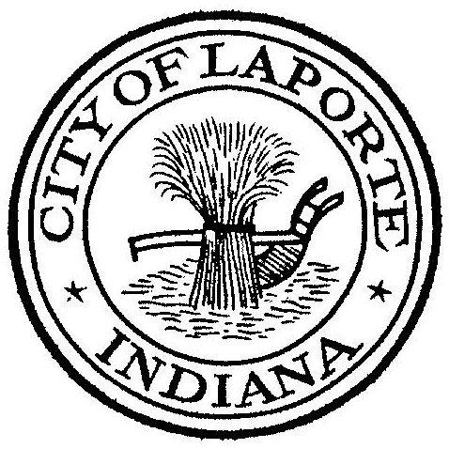
Board of Public Works and Safety
Jessica Romine, Member Tom Dermody, Mayor Mark Kosior, Member
City Hall 801 Michigan Ave., La Porte, IN 46350
Tuesday, April 4, 2023
9:00 AM
AGENDA
- Call To Order
- Pledge Of Allegiance
- Approval Of Minutes
- Public Comment: In Person and via Facebook Live
- Clerk-Treasurer: Claims Approval
Conflict of Interest Forms
Vehicle Inventory
Credit Card Inventory
- Department Head Reports
- New Business:
-Jim Kaminiski: City of La Porte Police Collective Bargaining Agreement
State Street Parking Lot-Parcel ID: 460635412002000043
-Paul Brettin: PD Vehicles Leases
Contract and Invoice for Purchase of La Porte K9
-Jerry Jackson: Generator Maintenance Agreement
Sewer Vac Truck Bids
Basement Backup Grant 815 Eason Ct
Monroe Manor Final Pay Request

8) Unfinished Business:
9) Other Business: Next regularly scheduled meeting: Tuesday, April 18, 2023 at 9a.
10) Adjourn

